An Application for Information Transfer, using Ultrasound Waves

Authors:
Yoni Grinberg ID: 307868257 Yoni.Grinberg@e.braude.ac.il
Bar Harush ID: 205713308 Bar.Harush@e.braude.ac.il

Group:26-1-D-7

Supervisor:
Dr. Elena Ravve

GitHub: https://github.com/yonigri92/Ultra_Sound_Data_Transfer_Many_To_Many

Abstract.
Standard wireless communication technologies such as Wi-Fi face significant limitations regarding signal containment, security and propagation through conductive media.
To address these challenges, this project presents a design and implementation of many-to-many ultrasonic data transfer network utilizing standard smartphone hardware which is capable of scalable network layer compatible with Android and IOS platforms.
Keywords:
- Primary Keywords: Ultrasonic Communication, Data-over-Sound, Many-to-Many Networking
- Protocol Keywords: CSMA/CA, RTS/CTS Handshake, Collision Avoidance
- Technical/Method Keywords: Frequency-Shift Keying (FSK), FFT (Fast Fourier Transform), Signal Processing.
- Platform/Context Keywords: Cross-Platform (Android & iOS), Acoustic Data Transmission

Chapter 1. INTRODUCTION:
The core idea for this project stems from the limitations identified in current wireless communication technologies, particularly when applied to challenging physical environments where RF (Radio Frequency) fails such as Conductive Media.

The project leverages the fact that acoustic waves (ultrasound) propagate exceptionally well through liquids and tissue, making it the essential alternative where RF fails.

The necessity for ultrasonic data transfer extends beyond physical medium constraints. Standard RF technologies, such as Wi-Fi and Bluetooth, operate in crowded frequency spectrums that are susceptible to electromagnetic interference and signal congestion. Furthermore, RF signals easily penetrate solid objects like walls, creating significant security risks known as "snooping," where data can be intercepted from outside the intended physical space. In contrast, ultrasonic waves are naturally contained by solid barriers, providing an inherent layer of physical security and privacy.

In this project, we address these challenges by developing a cross-platform application that enables many-to-many data transfer using ultrasonic waves. By implementing advanced collision avoidance protocols, the project establishes a reliable acoustic network that operates seamlessly across both Android and iOS devices, independent of traditional RF infrastructure.

1.1. Organization Of The Book
Chapter 1: INTRODUCTION
1.1. Organization Of The Book
1.2. Project Scope and Objectives?
1.3. Why Is The Project Not Trivial?
1.4. What Has Been Done Until Now?
1.4.1. What Is Wrong With What Is Done Till Now?
1.4.2. Proposed Solution and Implementation
1.4.3. System Implementation and Functional Improvements
1.5. Difficulties In Setting This Project
1.5.1. Algorithmic Challenges
1.5.2. Physical Layer Challenge
1.5.3. Implementation Challenge
Chapter 2: Background And Related Work
2.1. Reasons To Use Ultrasound
2.2. Specific Environmental Struggles
2.3. What Is Ultrasound Communication (Data Transmission Using Sound Waves Above The Human Hearing Range)?

2.4. Benefits Of Sending Data Over Sound: Summary
Chapter 3. Challenges and Solutions
Chapter 4: General Steps Of Implementation
4.1. Data Encoding: Frequency-Shift Keying (FSK)
4.1.1. Frequency Selection
4.1.2. Bit Duration
4.2. Connection Establishment: CSMA/CA With RTS/CTS
4.2.1. RTS\CTS Frame Structure
4.2.2 Transmitter Implementation
4.2.3. Receiver Implementation
4.2.4 Pseudo Code And Algorithms
4.2.5. Collision Avoidance Algorithm (CSMA/CA) & Flow
3.2.6 Cross-Platform Implementation (Android vs. iOS)
3.2.7 ACK Generation and Transmission
4.3. Many-to-Many Topology Discovery and Control Channel Protocol
3.3.1 Architectural Foundations and Channel Separation
3.3.2 The Four-Stage Topology Discovery Algorithm
3.3.3 Fault Tolerance: Dynamic Disconnection Detection
3.3.4 Mathematical Timing Analysis and Network Convergence Budget
Chapter 5: EXPECTED RESULTS and REALITY
Chapter 6: UML
Chapter 7: . Testing and Reality
7.1. Bit Packing And Fragmentation Logic
7.1.1. Checksum Calculation Accuracy
7.1.2 Packet Serialization
7.1.3 Frequency Analysis Algorithm
7.2 Physical Layer Testing
7.2.1. Bit Duration and Timing
7.3. Integration Testing
7.3.1. Single Packet Transmission
7.3.2. RTS/CTS Handshake Verification
7.4. Field Testing
7.4.1 Maximum Effective Range
7.4.2 Noise Immunity
7.4.3 Wall/Barrier Penetration Test
Chapter 8: FR\NFR Requirements
Chapter 9. Future Work and Scalability Horizons
9.1 Introduction and Physical Layer Bottlenecks
9.2 Distributed Multi-Initiator Discovery Framework (Starvation Mitigation)
9.3 Multi-Hop Mesh Relay Architecture (Range Extension)
9.4 Dynamic Framing and Expanded Addressing Space
Chapter 10: References

1.2. Project Scope and Objectives
The idea thus evolved from a simple acoustic link into a full many-to-many communication protocol design challenge. The current project's rationale is to bridge the gap between a lab-based physical demonstration and a robust, scalable, and secure network layer.
The objective is to establish a secure, multi-user ultrasonic network that proves the viability of this non-RF (Radio Frequency), acoustic method for applications in environments like operating rooms, laboratories, or personal proximity systems where the benefits of liquid/tissue penetration and physical security (signal containment) are paramount. This requires introducing a sophisticated channel arbitration method like CSMA/CA (Carrier Sense Multiple Access with Collision Avoidance) and ensure seamless cross-platform compatibility between Android and the iPhone Operating System (iOS).

1.3. Why is the Project Non-Trivial? While previous academic work successfully pioneered a basic one-to-one ultrasonic data link between two Android devices, the system lacks the network layer required for real-world utility. For any practical application (e.g., secure medical pairing, multi-party data exchange), the system needs to be scalable to allow multiple devices to simultaneously listen, transmit, and coordinate without data collision

1.4. What Has Been Done Until Now?
This project builds upon the foundational research and implementation conducted by previous engineering students at Braude College. Specifically, we acknowledge the work of Miras Safadi, Rani Hassan Smart Visit Card (SVC) [6], Tal Zilberman, Ariela Havkin Ultra Sound Data Transfer Many To Many [7], Taimor Fares and Fares Jaraisy Inaudible Information Transfer between Android Based Devices [8].
These teams successfully established Proof of Concept (PoC) for a one-to-one ultrasonic communication channel between two Android devices. Their key achievements included:
- Physical Layer Implementation: These teams researched and selected Frequency-Shift Keying (FSK) as the optimal modulation technique for acoustic data transfer [7][1].
- Frequency Selection: These teams determined that the frequency range of 18 kHz to 19 kHz was most effective for mobile speakers and microphones, remaining inaudible to humans while detectable by standard hardware [7][2].
- Data Processing: These teams implemented a flow using Fast Fourier Transform (FFT) to convert recorded audio from the time domain to the frequency domain to decode binary data [7][3].
1.4.1. What Is Wrong With What Has Been Done Until Now?
While the previous implementation succeeded in establishing a basic link, it lacked the necessary Network Layer and Cross-Platform capabilities required for real-world utility.
- Lack of Network Protocol (Scalability): The previous system was strictly limited to a one-to-one connection. It did not have a mechanism to handle multiple devices simultaneously. Without a channel arbitration protocol (like CSMA/CA), if three or more devices attempted to communicate, their signals would collide, rendering the data unreadable. It could not support a "many-to-many" topology.
- Single Platform Restriction: The previous project was developed exclusively for the Android operating system. In a real-world scenario (such as contact tracing or medical environments), users carry heterogeneous devices. A system that cannot communicate between an Android phone and an iPhone (iOS) has limited practical application.
1.4.2. Proposed Solution and Implementation
The project expands the communication channel from one- to -one, to many- to- many. We implemented a sophisticated channel arbitration method, specifically the Carrier Sense Multiple Access (CSMA/C) protocol, to manage network traffic.
The project successfully bridged the gap between a laboratory demonstration and a robust network by ensuring seamless cross-platform compatibility between Android and iOS.
1.4.3. System Implementation and Functional Improvements
To achieve a robust many-to-many network, several technical improvements were integrated into the system. The physical layer was upgraded from a binary link to 16-MFSK (Multiple Frequency Shift Keying) modulation. By utilizing 16 distinct carrier frequencies and a "bin-averaging" FFT (Fast Fourier Transform) approach, the project quadrupled data throughput while remaining resilient to frequency drift and "time smearing."
To ensure data integrity, we implemented a CRC-8 (Cyclic Redundancy Check) algorithm. This guarantees that any transmission errors caused by environmental noise are detected and discarded. Furthermore, to maintain system compatibility across different hardware architectures, the logic was refactored to use standardized Uint8List structures, ensuring consistent checksum results on both Android and iOS.
Finally, many-to-many coordination was achieved through the implementation of a CSMA/CA (Carrier Sense Multiple Access with Collision Avoidance) protocol. This protocol manages channel arbitration by sensing the acoustic medium before transmission, effectively preventing data collisions and enabling a seamless multi-user environment.
1.5. Difficulties In Setting This Project
1.5.1. Algorithmic Challenges
Collision Detection Constraints Implementing Standard Collision Detection (CSMA/CD), used in previous projects, was shown to be practically unfeasible in wireless acoustic networks due to hardware limitations. [9]
- Self-Interference: Mobile transducers operate in Half-Duplex mode. During transmission, the device’s own high-amplitude output saturates its receiver, making it impossible to detect incoming signals or interference simultaneously. [9]
- Hidden Node Problem: Two transmitters out of range of each other may transmit simultaneously to a central receiver, causing undetectable collisions at the destination. Conclusion: The system could not rely on real-time detection and therefore implemented Collision Avoidance (CSMA/CA) protocols like Request to send (RTS)/Clear To Send /(CTS). [3][6]
Physical Layer Challenge: Multipath Propagation & Inter-Symbol Interference (ISI)
- Indoor acoustic communication suffers from severe Multipath Propagation, where sound waves reflect off surfaces and reach the receiver at different times.
- The Issue: These delayed echoes overlap with subsequent data bits, causing Inter-Symbol Interference (ISI). This distorts the signal and can flip bits (0 vs 1).[4][5]
Implementation Challenge: Non-Deterministic OS Latency Developing for general-purpose mobile operating systems (Android & iOS) presented a Real-Time constraint.
- The Issue: Neither Android nor iOS are hard Real-Time Operating Systems (RTOS). System scheduling, background processes, and memory management can delay audio buffer delivery to the application layer. [9]
The Risk: These unpredictable delays cause Buffer Underflows, resulting in permanent loss of incoming signal segments.
Chapter 2. BACKGROUND AND RELATED WORK:
2.1 Reasons To Use Ultrasound
There are many technologies that can help with short-range data transfer and communication such as Wi-Fi and Bluetooth and even Apple's AirDrop is based on these technologies. These technologies rely on RF which in some environments - may cause interferences - may not be efficient, suitable or applicable.
Ultrasound transfer overcomes some of these limitations as high frequency soundwaves beyond the audible range of humans can be used to transfer small amounts of data over short distances while overcoming some of the limitations of RF transmissions without using specialized equipment such as radio transmitters. For these reasons ultrasound transfer may offer an alternative to the current relevant technologies.
The limitations of RF data transfer that Ultrasound Data Transfer can overcome are Signal Interference and Spectrum Congestion limitations.
Technologies like Wi-Fi and Bluetooth operate in specific, crowded frequency bands (e.g., 2.4 GHz, 5 GHz). [5]
This creates two major problems:
- Signal Interference
RF Interference: Devices interfere with each other. A signal from several devices may collide with each other leading to dropped connections, slower speeds, and poor reliability.
Furthermore, RF signals are also susceptible to electromagnetic interference from common household and industrial electronics, which can disrupt communication.

Ultrasound Overcomes this problem via not using RF waves at all as it simply uses sound waves instead, thereby unaffected by EM (Electromagnetic radiation), furthermore it avoids the crowded radio spectrum thereby doesn’t have to compete with a lot of other devices.

Security and Signal Containment
RF Security Risk: RF signals are difficult to contain; they easily pass through solid objects such as walls, doors or windows. This is often beneficial for whole-home coverage, it also creates a significant security risk. A signal can be intercepted, or "snooped," by a third party outside the intended room or building, requiring complex encryption to secure the data.
How Ultrasound Overcomes This: Ultrasound waves are physical vibrations and are easily blocked by solid objects. This means the signal is physically confined to a single room. This property acts as a natural security feature, making it nearly impossible for someone in an adjacent room or outside the building to intercept communication [7], thus providing inherent privacy.
On that note, it's also important to mention that it's simple to determine the physical limits of this 'sound barrier.' The insecure area is strictly limited to the physical space where the soundwave can be detected, unlike RF signals, where it's difficult to know the boundary.

2.2 Specific Environmental Struggles

RF Limitation
RF waves propagate very poorly through conductive media, especially water. Saltwater heavily attenuates radio signals, making Wi-Fi and Bluetooth completely unusable for underwater communication.[11]
This same principle applies to the human body, which is composed of RF signals struggle to pass through tissue, requiring high power, which can be inefficient and potentially cause unsafe tissue heating.
Such issues make RF unusable for certain cases such as medical ones. [11]

How Ultrasound Overcomes It
Ultrasound excels in the very environment where RF fails.
● Excellent Propagation in Liquids:
As a mechanical wave, ultrasound travels exceptionally well through liquids. This is why it's the standard for SONAR (underwater) and medical imaging (in-body) [10].
● Ideal for In-Body Communication:
It can be used for low-power, safe communication between medical implants and external devices, overcoming the high signal loss and heating concerns associated with RF [10].
2.3 What Is Ultrasound Communication?

]
Ultrasound communication is a wireless data transmission method that utilizes acoustic (sound) waves as the physical carrier medium instead of electromagnetic (radio) waves. It operates within the near-ultrasound spectrum, typically between 20 kHz and 24 kHz[11]. This frequency range is specifically chosen because it lies just above the nominal upper limit of human hearing, yet remains well within the physical acoustic reproduction and sampling capabilities of standard, off-the-shelf speakers (transmitters) and microphones (receivers).
To understand the engineering decisions behind utilizing ultrasound, it must be compared to traditional Radio Frequency (RF) and Electromagnetic (EM) wireless protocols. Each technology represents a different engineering trade-off between range, data rate, hardware complexity, and security [5]:

Technology | Use Case | Effective Range | Wave Type | Notes
Ultrasound Communication | Data transfer using high-frequency sound waves | ~2–5m | Acoustic (>20 kHz) | Works in liquids; blocked by walls (secure).
AirDrop | File sharing (Apple devices) | 10m | Bluetooth + Wi-Fi Direct | Uses Bluetooth for discovery, Wi-Fi for transfer.
Handoff / Continuity | Passing activity between Apple devices (Safari tabs, calls, clipboard) | 10m | Bluetooth + Wi-Fi Direct | Uses RF
Apple Pay (NFC) | Secure contactless payments | 13.56 MHz (RF) | Near-Field Communication (RF) | Extremely short-range radio. Designed for secure, authenticated exchanges.

Table 1: Comparison of Wireless Communication Technologies [5].

2.4. Benefits Of Sending Data Over Sound: Summary
Operational Independence (Off-Grid Capability): as sound can operate on a peer-to-peer basis it does not require Sim card, any infrastructure and can work in areas where RF coverage does not exist.
- Cost effectiveness: since we use sound to transfer data all that is required is a receiver, output device and the capability to compute the application, which means it can run on devices that do not have RF access (antenna).
- Enhanced Security :as seen in Section 2.1.2 since ultrasound waves have a short distance life, they offer privacy that RF cannot.
- Environmental Resilience: as seen in Section 1.1.3
ultrasound allows access through materials that therefore thereby be applied to transfer information where RF is lacking.
- Ease of Integration: since the requirements for operations are so minimal, technology can be implemented on different platforms much more easily than other technologies.
Chapter 3. Challenges and Solutions

      - Programming language in a work environment:
As part of the project requirements, we were required to learn and work with a new programming language called DART, a modern high-level language based on object-oriented development. The language was created as a programming tool for the FLUTTER development environment. This is a development environment designed to develop uniform code for various platforms such as mobile, web, desktop, etc. The main idea was to develop uniform code that could run on any platform.
Like any new language and new development environment, we had to adapt to it in a relatively short time to start the project, this was the first practical task.

      - Audio library selection process:
The flutter development environment comes with several built-in audio libraries that you can work with, In Flutter, audio libraries are generally divided into three categories based on how much control they give you over the hardware.
a. High-Level Libraries
These are designed for standard apps that need to play music or sound effects. They handle file decoding (MP3, WAV) and streaming automatically, like "audioplayers" and "just_audio".
Why aren't they ideal for the project? These libraries often introduce extra buffering and compression, which can distort the ultrasonic sine waves.

b. Low-Level Libraries (Raw PCM Streaming)
This is the category that the project falls into. Instead of playing a file, we are generating a raw stream of numbers (PCM data) representing your bitstream and injecting it directly into the audio buffer, like "raw_sound" and "flutter_sound".

We compared these two libraries, tried both to see which one would meet the needs of the project and be simpler and easier to use. We encountered problems with the "flutter_sound" library, it did not produce the required sound consistently and correctly, and sometimes even faked sounds. Therefore, we chose to use the "raw_sound" library, it worked most consistently and reliably.

c. The Engineering Approach: Dart FFI & Native Plugins
When the Flutter/Dart bridge is too slow for real-time DSP, engineers move the logic to the Native layer.
Oboe (Android): A C++ library by Google designed for lowest-latency audio.
Dart FFI (Foreign Function Interface): This allows us to write code and call functions that were written in C and call it directly from Flutter.
Those are low level libraries, this is not our first choice, because this is the most complex path to pick.
      - Data Integrity and System Compatibility
The Challenge: Initially, the CRC calculations were implemented using bitwise operations on generic int types. We discovered that in Dart (specifically when interfacing with the Android audio layer), integer handling can vary across different architectures (64-bit vs. 32-bit). This led to inconsistent checksum results between devices.
The Solution: The messenger logic was refactored to use Uint8List and Byte Data exclusively. This ensures strict memory alignment to 8-bit bytes and prevents overflow errors, guaranteeing that the CRC remains consistent regardless of the underlying hardware architecture.
      - DSP Challenges – Frequency vs. Time Resolution (The FFT Trade-off)
The Initial Stage: To establish a basic data link, the project initially utilized Binary FSK with two frequencies: 18kHz (bit '0') and 20kHz (bit '1'). Distinguishing between these frequencies required high frequency resolution. Using a sampling rate of 44,100Hz and an FFT window (N) of 512 samples, the frequency resolution was calculated as:
$∆f= \frac{f_{s}}{N}= \frac{44100}{512}≅86Hz$
      - The Challenge (Time Smearing): While increasing the window size (N) improves frequency precision, it introduces "Time Smearing." A large window makes it difficult to detect the exact transition points between bits (the Baud Rate timing), as the window may overlap across two different bit periods, corrupting the data.
The Solution: To maintain a small, responsive window while ensuring reliability, we implemented a Frequency Bins (Buckets) approach. Instead of searching for a single peak, we defined an energy "bucket" around the target bin. Averaging the energy within these buckets made the initial 18kHz/20kHz system robust against environmental noise and hardware variance.
$$Target Bin=round\left(\frac{f_{target}*N}{f_{s}}\right)$$Averaging the energy within these buckets makes the system robust against slight frequency drifts caused by environmental noise or hardware variance.
      - Timing Synchronization and Clock Drift
The Challenge: We observed that even between identical devices (e.g., two Galaxy A36 units), there are minor variations in the hardware's internal sampling rate. This Clock Drift causes the receiver's frame timing to gradually desync from the transmitter, eventually leading to packet corruption and CRC failure.
The Solution: We developed a "Symbol-Based Forgiving Synchronization" mechanism. Instead of relying on a single FFT frame, the system accumulates detection counts for a specific frequency. A Symbol is pushed to the decoder only after it has been consistently detected for 80% of its expected duration (based on the 10 Baud rate). This prevents "false triggers" from transient noise and handles minor clock drift between devices
      - Bandwidth Optimization and Signal-to-Noise Ratio (SNR)
The Challenge: At frequencies of $20kHz$and above, the frequency response of the A36 devices drops sharply, causing the signal to be overwhelmed by ambient white noise.
The Solution: We optimized the operational bandwidth to the 17,000Hz – 19,700Hz range. While hardware response drops at higher frequencies, this wider 2.7kHz bandwidth is necessary to provide enough separation between the 16 channels, ensuring that each "symbol bucket" does not overlap with its neighbor (Inter-Channel Interference)
      - Hardware Constraints: Despite the success of the "Buckets" approach, testing revealed that many mobile devices have a sharp drop in microphone sensitivity at 20kHz, leading to inconsistent results. Furthermore, the binary (0/1) approach offered limited throughput.
The Solution: To overcome this, we evolved the system to 16-MFSK. By utilizing 16 distinct frequencies within a more stable acoustic range (17kHz – 19.7kHz), we quadrupled the data rate (4 bits per symbol) and avoided the hardware limitations of the 20kHz ceiling. This transition leveraged our "Buckets" logic to manage 16 simultaneous channels with high precision and zero cross-channel interference.
      - Network Layer – Symbol Alignment Lag in the FIFO Buffer:
The Challenge: The receiver experienced a consistent "one-packet lag," processing and responding to an incoming frame (such as a Handshake or ACK) only after the transmitter had already initiated the subsequent transmission.
The Solution: The dispatcher’s frame-detection logic was refactored to scan the sliding window dynamically based on the expected physical boundaries of each packet type
      - Link Layer – Stop-and-Wait Timeout and Listening Window Optimization
The Challenge: When attempting to stream sequential datasets (e.g., a multi-packet file transfer of up to 254 packets), the protocol suffered from massive dead-time or collapsed into infinite retransmission loops. Because the architecture implements an asynchronous Stop-and-Wait mechanism—where the transmitter initiates background audio playback and concurrently fires a thread-sleep timer—the legacy 2-second worker delay created a severe timing bottleneck at 10 Baud.

A standard Data packet requires exactly 1.6 seconds of physical airtime. A 2-second timeout left a microscopic 0.4-second window for the remote device to capture the packet, process it, and reply. Since a fast ACK frame (10 symbols) requires 1.0 second to play, it was consistently truncated by the transmitter's premature timeout, causing corrupted checksums and triggering redundant, cascading retries.

The Solution: We optimized the thread’s sleep intervals to perfectly align with the physical acoustics of the 10 Baud environment. The data packet transmission delay was tuned to exactly 2700ms. This precise allocation breaks down into:

- 1.6 seconds for local background audio execution.

- 1.0 second of a dedicated, uninterrupted listening window to completely capture the incoming remote ACK.

- 100ms Guard Interval to allow local multipath reflections (room echoes) to fully decay before shifting protocol states.

This optimization minimizes idle dead-time while providing robust channel availability for control signaling.

      - Physical/Application Layer Crossover – Asynchronous Audio Overlap on Packet Drop
The Challenge: In high-noise environments where a specific data packet exhausted its maximum retry threshold (5 attempts) without receiving an ACK, the dispatcher is designed to drop the frame and immediately fetch the next packet from the queue. However, stress testing revealed that the packet immediately following a dropped frame would always arrive corrupted at the receiver.

The Solution: The packet-dropping routing inside the thread was updated with an isolated 1700ms cleanup delay. This structural pause forces the worker loop to remain suspended until the background audio track of the failed 5th attempt finishes its 1.6-second physical playback cycle entirely. By injecting an intentional 100ms buffer of silence to clear the acoustic medium of lingering waves, the system guarantees a pristine, unpolluted acoustic channel before the next sequential data frame is launched into the air.

      - Acoustic Self-Reception (Echo) Filtering
The Challenge: Acoustic Loopback Because the speaker and microphone share the same physical medium and frequencies, the device constantly hears its own transmitted signals (Handshake, Data, ACK).
The Solution: Introduced a dedicated
ignorePackets (Map<String, DateTime>) map.
Outgoing packets are converted into string keys using .join(',') to ensure content-based matching. If the received packet is inside the map, then we ignore it.
      - Architectural Extension Without Code Regression – Wrapper Pattern for Asynchronous Control Tones

The Challenge:
Integrating the new dual-frequency Binary-FSK control channel (Discovery and Busy tones) required a fundamental expansion of the system's Digital Signal Processing (DSP) capabilities. However, the existing FskModulationLogic class was already fully optimized, tested, and validated for structural 16-FSK frame packet data. Modifying this core logic directly posed a severe architectural risk, as tampering with the verified mathematical loop inside generateNextBuffer could introduce regression bugs, destabilize time-critical guard interval calculations, and break features that had already passed quality assurance.
The Solution:
To expand functionality with zero code degradation. In fact, the architecture was extended using the Wrapper Pattern (FskWrapperLogic). Instead of refactoring the legacy code, the original FSK class was encapsulated using composition. For standard data transmissions, the wrapper acts as a transparent pass-through layer. When a control channel signal is required, the wrapper intercepts the process and handles continuous sine wave generation directly at the raw audio sample level (calculating exact samples for a 300ms cycle), completely bypassing the complex frame-parsing mechanism. This structural isolation guarantees that the stable, verified codebase remains completely untouched while seamlessly injecting the new real-time synchronization tones.

14. Network Latency Optimization via Opportunistic Overhearing and Root-Proximity Priority
The Challenge:
Time Budget Constraints in Acoustic Multi-Hop Chains. In an acoustic mesh network, transmitting an 8-byte FSK data frame over multiple sequential hops (e.g., from a Grandchild node to a Parent node, and then from the Parent to a Grandparent node) incurs a severe latency penalty—approximately 1.6 seconds per acoustic hop. In a multi-device network deployment, this linear hop-by-hop traversal accumulates massive delays, rapidly exhausting the protocol’s time budget and dragging down the overall network synchronization efficiency.
The Solution:
Introduced an Opportunistic Routing (Wireless Overhearing) mechanism combined with a Root-Proximity Priority scheduling algorithm. Since acoustic waves propagate spherically throughout the shared physical medium, a Grandparent node naturally overhears the raw data frame transmitted by a Grandchild to its direct Parent. To safely exploit this, nodes closer to the topology root are assigned higher channel priority (meaning shorter deterministic backoff timers).

Upon overhearing the Grandchild's packet, the Grandparent immediately calculates its high-priority window and broadcasts a targeted upstream ACK addressed specifically to the Parent. When the Parent hears this targeted ACK, it recognizes that the Grandparent has already successfully captured the data straight from the source. The Parent then immediately cancels its own pending upstream data transmission and goes to sleep. This opportunistic bypass mechanism eliminates redundant packet transmissions, saving a clean 1.6 seconds per bypassed link while safely preventing acoustic collisions.

Chapter 4. GENERAL STEPS OF IMPLEMENTATION,
The implementation leverages the principle of Data-over-Sound, utilizing existing device hardware (microphone and speaker) to exchange data.

4.1. Data Encoding (FSK):[1][2]
The application uses Frequency-Shift Keying (FSK) to encode binary data onto ultrasonic sound waves.
Frequency Shift Keying (FSK) is a digital modulation technique extensively utilized in modern telecommunications and data transmission systems. It involves changing the frequency of a carrier signal to carry information.
The simplest FSK is binary FSK (BFSK, which is also commonly referred to as 2FSK or 2-FSK), in which the carrier is shifted between two discrete frequencies to transmit binary (0s and 1s) information.
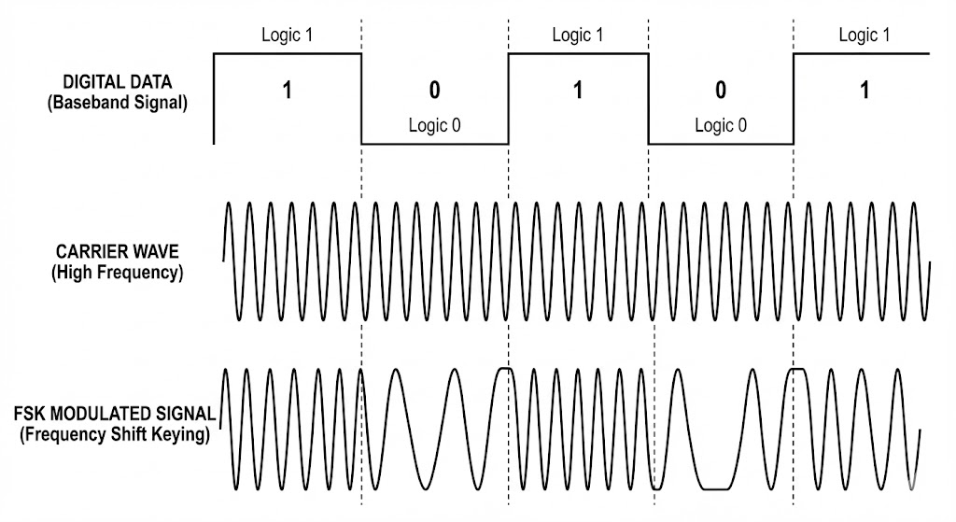
Figure 1: Time-domain representation of Binary Frequency-Shift Keying (BFSK) modulation, illustrating the shift between carrier frequencies, (Figure Created by Google "nano banana pro" AI Model).
4.1.1 Frequency Selection:
The communication channel is set between 18 KHZ and 20 KHZ, which are generally inaudible to humans. A bit '0' is signified by transmitting on 18 KHZ, and a bit '1' is signified by transmitting on 20 KHz.
4.1.2 Bit Duration:
The optimal duration time for playing a tone representing one bit is 0.5 milliseconds. Piezoelectric components (used for ultrasonic transmission like speakers) behave like a spring, they take time to start vibrating at full amplitude and time to decay. At a typical frequency (~ 20kHz) with a single wave period is T = 50 microsec (T = 1/F). A standard speaker typically requires about 5 cycles to reach full amplitude (Rise Time). We can calculate the minimal Rise Time: 5 cycles * 50 microsec = 0.25 milliseconds. To ensure the signal reaches a stable steady state after the initial rise time, and to allow for sufficient sampling by the receiver, a safety factor of 2 was applied 0.25 milliseconds * 2 = 0.5 milliseconds.

4.2 Connection Establishment:
CSMA/CA with RTS/CTS:
CSMA is a basic method that controls the communication of multiple participants on a shared and decentralized transmission medium. However, this is now available in three different variants, which depend on the transmission medium. While CSMA/CA is mainly used in wireless networks, CSMA/CD was developed for Ethernet, and CSMA/CR is used in controller area networks (CAN), which are mainly used in cars and machines. [3]
Request to send and clear to send (RTS/CTS):
The frames “Request to Send” (RTS) and “Clear to Send” (CTS) are part of the optional extension CSMA/CA RTS/CTS. This procedure is upstream of the actual data transmission. If a participant determines that the transmission medium is free, the device first sends an RTS frame to the participant to receive the data. With this, the output computer makes it clear that it wants to start a transmission and will occupy the transmission medium for a certain time.
The receiver, in turn, sends a CTS frame to the original sender. As with the RTS frame, all other participants in the range are informed that the transmission is currently occupied and the transmitter is enabled for transmission. Only then does the original device start transmitting the data. Now it is not possible for the participants in a wireless network to detect collisions or other interference during transmission. For this reason, the receiving station needs to send an acknowledgement (ACK) when the data packet has arrived correctly.
If the ACK frame doesn’t appear, the sender of the data assumes that a complication has occurred and resends the data packet. The station has a preferential right to use the medium and doesn’t have to wait again for the channel to be free. The three frame types each consist of several fields.

RTS/CTS Sequence:
            - RTS (Request to Send): The transmitter sends a short control frame indicating intent to transmit
            - Wait (SIFS): The transmitter enters a listening state for a predefined window (Timeout).
            - CTS (Clear to Send): If the receiver is idle, it responds with a CTS frame.
            - Data Transmission: Upon receiving the CTS, the transmitter sends the full data packet.
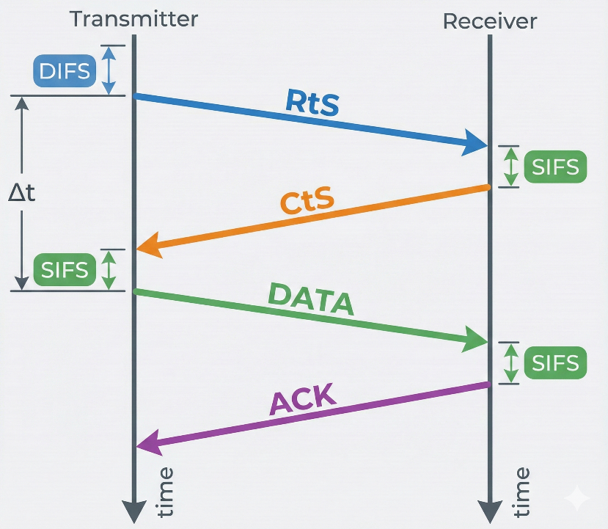

Figure 2: Sequence diagram of the CSMA/CA protocol utilizing the RTS/CTS handshake mechanism, (Figure Created by Google "nano banana pro" AI Model).

4.2.1 RTS/CTS Frame Structure:
Each transmission is a fixed 56-bit frame. The transmission time for the full frame is approximately 28 milliseconds (56 * 0.5ms). The frame components are:
1. Starting character 'F' (4 bits).
2. User ID (40 bits).
3. Separating character 'F' (4 bits).
4. Checksum (8 bits), calculated by Cyclic Redundancy Check (CRC) the characters/digits of the data section.

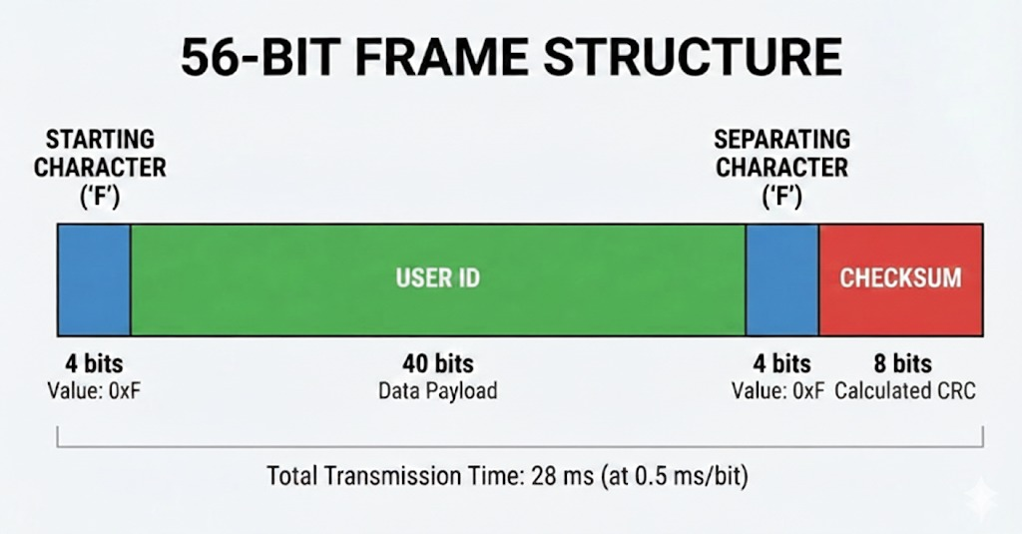
Figure 3: Schematic breakdown of the 56-bit Ultrasonic RTS/CTS Frame, (Figure Created by Google "nano banana pro" AI Model).

4.2.2 Transmitter Implementation:
The transmission process uses the Android API's ‘AudioTrack’ or IOS API's ‘AVAudioEngine’.
Data Frame Structure:
To accommodate the physical constraints of the ultrasonic channel (limited bandwidth and a transmission rate of 0.5ms per bit), the protocol utilizes a lightweight, byte-oriented frame structure. The design prioritizes minimal overhead while ensuring robust synchronization and support for multi-packet fragmentation.
The total fixed overhead per frame is 8 Bytes (approx. 32ms transmission time), ensuring high throughput for user data.
Order | Field Name | Size | Value / Type | Function
1 | Preamble | 4 Bytes | 0xAAAAAAAA | Synchronization: A training sequence enabling the receiver to perform clock recovery and stabilize AGC (Automatic Gain Control).
2 | Sync Word | 1 Byte | 0xFF | Start Delimiter: A unique marker indicating the end of the training phase and the start of valid data.
3 | Frag Info | 1 Byte | Bit-Packed | Management: Contains both the packet index and the total packet count.
4 | Length | 1 Byte | 0x00 - 0x40 | Payload Size: Indicates the number of data bytes in the current frame (N).
5 | Payload | N Bytes | ASCII Data | User Data: The actual text content being transmitted.
6 | Checksum | 1 Byte | Calculated | Integrity: An CRC-8 based checksum for error detection.
Table 2: Frame Layout Table [6]

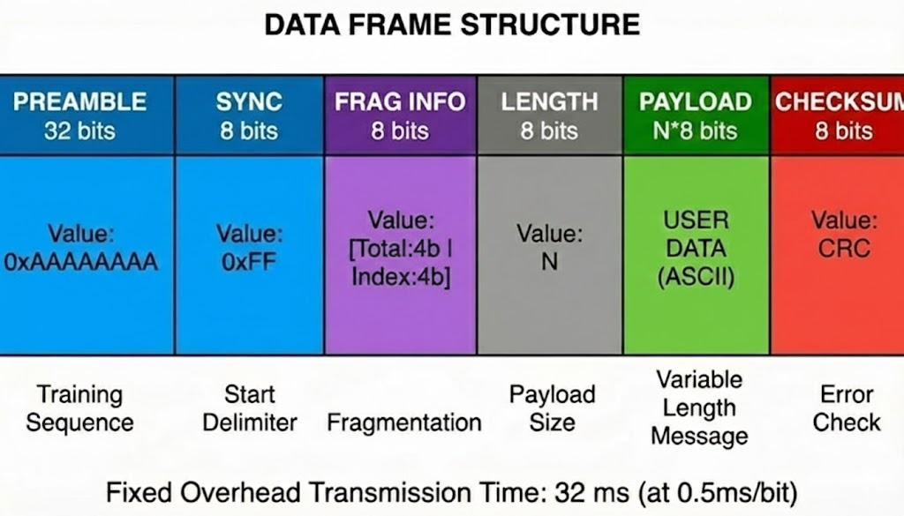
Figure 4: Schematic breakdown of the Data Frame. (Figure Created by Google "nano banana pro" AI Model).

1. Tone Generation: The application iterates over the binary sequence (the frame) and assigns the corresponding high (20 KHZ) or low (18 KHZ) frequency tone.
2. Audio Output: The synthesized audio track is played with the highest amplitude to transmit the data.
3. Flow Control: Transmission is strictly controlled by the Collision Avoidance Protocol (Section 2) to ensure the channel is idle before sending.
Transmitted side pseudo code and algorithms:
1.SYSTEM CONSTANTS & CONFIGURATION
CONST SAMPLE_RATE = 44100 // Hz
CONST BIT_DURATION = 0.0005 // 0.5 ms
CONST SAMPLES_PER_BIT = 22 //
CONST FREQ_LOGIC_0 = 18000 // Hz
CONST FREQ_LOGIC_1 = 20000 // Hz
CONST RAMP_PERCENT = 0.10 // 10% of bit duration for smoothing
// Protocol Constants
CONST PREAMBLE_SEQ = 0xAAAAAAAA // 32-bit Training Sequence
CONST SYNC_BYTE = 0xFF // Start Delimiter

2. PACKET SERIALIZATION
FUNCTION ConstructPacket(userMessageString, packetIndex, totalPackets):
// Initialize buffer
List<Byte> frameBuffer = new List()
// Add Preamble (4 Bytes)
frameBuffer.addInt32(PREAMBLE_SEQ)
// Add Sync Word (1 Byte)
frameBuffer.addByte(SYNC_BYTE)
// Add Fragmentation Info (1 Byte)
// Bit Packing: Upper Nibble = Total, Lower Nibble = Index
Byte fragInfo = (totalPackets << 4) | (packetIndex & 0x0F)
frameBuffer.addByte(fragInfo)
// Add Payload Length (1 Byte)
Byte length = userMessageString.length()
frameBuffer.addByte(length)
// Add Payload Data & Calculate Checksum
// Initialize CRC-8 (Start value is typically 0x00 or 0xFF)
Byte crc = 0x00
FOR each char IN userMessageString:
frameBuffer.addByte(char)
// Update CRC using a standard polynomial algorithm
crc = ComputeCRC8(crc, char)
END FOR

// Add Checksum (Still 1 Byte for 8-bit CRC)
frameBuffer.addByte(crc) // Serialization
// Convert the Byte List into a flat array of Bits
BitStream bits = ConvertBytesToBits(frameBuffer)
RETURN bits
END FUNCTION
//Helper Function
FUNCTION ComputeCRC8(currentCrc, newByte):
Byte data = currentCrc XOR newByte
FOR i = 0 TO 7:
IF ((data AND 0x80) != 0) THEN
// Polynomial 0x07 (Standard CRC-8)
data = (data << 1) XOR 0x07
ELSE
data = (data << 1)
END IF
END FOR
RETURN data
END FUNCTION
3. PHYSICAL MODULATION
FUNCTION TransmitSignal(bitStream):
// Initialize Audio Hardware
AudioTrack track = InitAudioTrack(SAMPLE_RATE, MODE_STREAM)
track.play()
Double phase = 0.0 // Tracks phase to ensure continuity (FSK)
INT rampSamples = SAMPLES_PER_BIT * RAMP_PERCENT
// Transmission Loop
FOR each bit IN bitStream:
// Frequency Selection
IF (bit == 0) THEN
targetFreq = FREQ_LOGIC_0 // 18 kHz
ELSE
targetFreq = FREQ_LOGIC_1 // 20 kHz
END IF
// Sample Generation
Float buffer[SAMPLES_PER_BIT]
FOR j = 0 TO SAMPLES_PER_BIT - 1:
// Calculate angle based on previous phase
angle = 2 * PI * targetFreq * (j / SAMPLE_RATE)
sample = sin(angle + phase)
// Amplitude Ramping
IF (j < rampSamples):
sample = sample * (j / rampSamples)
ELSE IF (j > SAMPLES_PER_BIT - rampSamples):
reversedIndex = SAMPLES_PER_BIT - j
sample = sample * (reversedIndex / rampSamples)
END IF
buffer[j] = sample
END FOR
// Update Phase
phase = phase + (2 * PI * targetFreq * BIT_DURATION)
// Write to Hardware
track.write(buffer, SAMPLES_PER_BIT)
END FOR
// Cleanup
track.stop()
track.release()
END FUNCTION

4. MAIN EXECUTION
FUNCTION MainTransmit(textInput):
// Serialize Data
BitStream readyBits = ConstructPacket(textInput, 0, 1)
// Transmit Audio
TransmitSignal(readyBits)
END FUNCTION

4.2.3. Receiver Implementation:
The reception process uses the Android API's ‘AudioRecord’ or IOS API's ‘AVAudioRecorder’.
1. Recording: The device listens to and records audio from the input hardware.
2. Decoding and Conversion: The recorded audio data (in the time domain) is converted to the frequency domain using Fast Fourier Transform. This process identifies the dominant frequency in each time chunk, converting the analog signals back into binary digits ('0' or '1').
3. Error Check: Once the binary message is decoded, the receiver verifies the frame structure (start/separation flags) and the Checksum.
4. Error Signal: If the calculated checksum does not match the received checksum, or if flags are missing, the receiving device immediately transmits an error signal back to the sender.
5. Local Storage: If the checksum is verified, the data (other user's ID, time of encounter) is saved locally in the device's database. Encounters lasting 15 minutes or more are flagged for potential upload to the cloud.
4.2.4 Pseudo Code And Algorithms:
To demodulate the FSK signal, the system requires an efficient method to analyze frequency components within the received signal buffer. Two primary algorithms were evaluated:
1. Fast Fourier Transform - FFT (Spectral Analysis):
FFT provides a complete frequency spectrum analysis of the signal O(N*log N).
2. The Goertzel Algorithm (Targeted Detection):
This algorithm is optimized for detecting specific, pre-known frequencies (in our case, 18kHz and 20kHz). It functions as a digital band-pass filter with extremely low computational complexity O(N).
Adaptive Strategy: The primary implementation utilizes the FFT Algorithm due to its very well known, proven to be fast and reliable in the DSP world. However, the system architecture retains the flexibility to switch to Goertzel, During the testing phase, empirical benchmarks will be conducted to verify that the 2kHz bandwidth separation (Guard Band) between Logical '0' (18kHz) and Logical '1' (20kHz) is sufficient for reliable detection over the acoustic channel.
1. SYSTEM CONSTANTS & CONFIGURATION:
CONST AudioSampleRate = 48000
CONST BitDurationSeconds = 0.0005 // 0.5 ms
CONST SamplesPerBit = 24 // 48000 * 0.0005
CONST FFT_WindowSize = 128
CONST NoiseThreshold = 500.0
// Calculated Frequency Indices for FFT [Index = (Freq * FFT_Size) / Rate]
CONST TargetIndex_18k = 48 // (18000 * 128) / 48000
CONST TargetIndex_20k = 53 // (20000 * 128) / 48000
// MAIN RECEIVER LOGIC
2. FUNCTION StartReceiver():
// Initialization
Instantiate AudioRecord as AudioInput
Float RawSampleBuffer[SamplesPerBit] // Size: 24
Complex ComplexFFTBuffer[FFT_WindowSize] // Size: 128
String ReceivedBitStream = ""
Boolean IsListening = TRUE
// Start Hardware Capture
AudioInput.startRecording()
// Main Processing Loop
WHILE (IsListening):
// Read Raw Audio Chunk in Real-Time
SamplesReadCount = AudioInput.read(RawSampleBuffer, 0, SamplesPerBit)
// Zero Padding Prepare for FFT
// Extends the 24 samples to 128 to improve spectral resolution
FOR i = 0 TO FFT_WindowSize - 1:
IF (i < SamplesPerBit):
ComplexFFTBuffer[i].Real = RawSampleBuffer[i]
ELSE:
ComplexFFTBuffer[i].Real = 0
END IF
ComplexFFTBuffer[i].Imaginary = 0
END FOR
// Converts time-domain samples to frequency domain
SpectrumOutput = FastFourierTransform(ComplexFFTBuffer)
// Get magnitude at specific target bins
Amplitude_18k = Magnitude(SpectrumOutput[TargetIndex_18k])
Amplitude_20k = Magnitude(SpectrumOutput[TargetIndex_20k])
// Demodulation Logic (Decision)
DetectedLogicBit = -1 // Default state (Idle)
// Check if signal is above noise floor
IF (Amplitude_18k > NoiseThreshold OR Amplitude_20k > NoiseThreshold):
// Compare which frequency is dominant
IF (Amplitude_20k > Amplitude_18k):
DetectedLogicBit = 1
ELSE:
DetectedLogicBit = 0
END IF
END IF
IF (DetectedLogicBit != -1):
ReceivedBitStream.append(DetectedLogicBit)
IF (PacketComplete(ReceivedBitStream)):
IsListening = FALSE
END IF
END IF
END WHILE
4. Cleanup
AudioInput.stop()
AudioInput.release()
END FUNCTION

4.2.5 Collision Avoidance Algorithm (CSMA/CA):
Since collision detection is nearly impossible in wireless acoustic networks, the system relies heavily on a specialized Carrier-Sense Multiple Access with Collision Avoidance (CSMA/CA) protocol, designed to support a network of up to 15 devices in the optimal reception area (2-meter radius). The protocol utilizes unique, prime number-based waiting periods to minimize collision probability.
A. Waiting Periods (IFG):
Each device is assigned two unique prime numbers to calculate its waiting periods (Inter-Frame Gap, or IFG):
1. Regular Base Waiting Period (RBWP): A high prime number (range 2503–4493). This determines the main cycle period (approximately 5 minutes) between regular transmission attempts.
2. Minimal Base Waiting Period (MBWP): A lower prime number (range 59–1499). This is used as a shorter waiting period in case of a busy channel or a detected error/collision, to ensure the device gets another chance to transmit quickly (avoiding starvation).
B. The CSMA/CA Protocol Flow:
The device continually cycles between listening and transmitting based on the timer (RBWP or MBWP).
1. Frame Ready (RBWP Timeout): When the RBWP timer expires, the device prepares to transmit.
2. Channel Check: The device checks: if the frequency (18–20 KHZ) is idle (silent) or busy (not silent).
3. If Busy: The device defers transmission and initiates a backoff period equal to its Minimal Base Waiting Period (MBWP). Once the MBWP timer expires, it checks the channel again. The device remains in this backoff loop until the channel is clear, ensuring rapid re-transmission and preventing starvation
4. If Idle: The device transmits the frame.
5. Wait: The sender enters listening to mode and waits for 2,000 milliseconds (2 seconds) for an error signal (collision/error detection) from any receiver.
6. Collision Handling: If an error signal is received: The sender concludes a collision, or transfer error occurred. It switches to listening mode and sets the timer to the shorter MBWP before attempting a re-transmission.
If no error signal is received: The transmission was successful. The device resets the timer to RBWP for the start of the next 5-minute cycle.

4.2.6 Cross-Platform Implementation (Android vs. iOS):
A. Android Implementation:
The entire project is explicitly an Android Based Application. The implementation relies on the Java\Kotlin libraries and the Android Integrated Development Environment (IDE).
Key Components: The core functions utilize Android-specific APIs (`AudioTrack` for playing sound and `AudioRecord` for recording sound). The application is designed to run as a Service in the background (24/7).

B. iOS Implementation:
Low-Level AudioRecord/AudioTrack Equivalent: Core Audio (Remote I/O Unit): The most direct, low-latency access to audio hardware.
High-Level Equivalent:
AVFoundation (AVAudioEngine): A modern, simpler API for managing input (inputNode) and output (outputNode).
Key Challenge (24/7 Background): iOS heavily restricts background execution.
The potential solution is the audio Background Mode, but this is subject to system limitations and strict Apple review.
4.2.7 ACK Generation and Transmission:
The acknowledgment (ACK) transmission process is responsible for closing
the feedback loop and ensuring reliable, bi-directional communication over the
ultrasonic channel.
ACK Frame Structure: To minimize channel occupancy
and ensure rapid feedback before transmitter timeouts occur, the protocol
utilizes an ultra-lightweight, bit-aligned ACK frame structure. The design
transmits only the 20 bits required for packet identification and validation
The total frame size is exactly 20 bits (2.5 Bytes),
which translates to a minimal transmission time of just 10ms (at 0.5ms per
bit), drastically reducing the probability of acoustic collisions on the
channel.

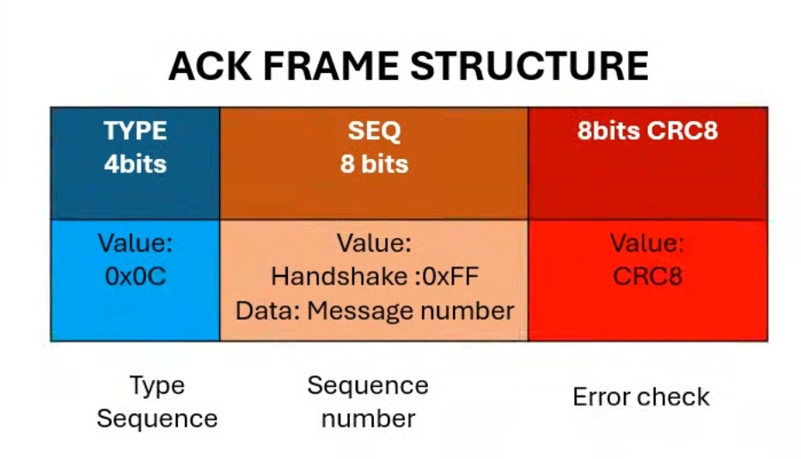

Figure 5: Schematic breakdown of the Ack Frame.

In our implementation we have decided to go with different modulation methods:
In basic digital modulation (like Binary-FSK or 2-FSK), one bit is transmitted at a time (0 or 1). In 16-FSK, we transmit groups of bits.
- Symbol Structure: The system takes the incoming data stream (zeros and ones) and groups them into chunks of 4 bits. Each 4-bit chunk is called a "symbol."
- Why 16? Because a group of 4 bits can create exactly 16 different combinations (2^4 = 16), ranging from 0000 to 1111.
- Frequency Allocation: Each of the 16 possible combinations is assigned its own unique physical frequency (f0 through f15).
  - For example: 0000 might be transmitted as 17,000 Hz.
  - 0001 might be transmitted as 17,200 Hz... and so on.
This is the feq values from the code:
this.freq = const [
17054.3,17226.6,17399.8,17571.1,17743.4,17915.6,18087.9,18260.2,18432.4,18604.7,18777.0,18949.2,19121.5,19293.8,19466.0,19638.3],

The true power of 16-FSK lies in its time efficiency; to transmit 40 bits per second in standard 2-FSK, you would need to change the frequency 40 times every second. In 16-FSK, to achieve that same 40 bps, we only need to change the frequency 10 times a second. This means your speaker, microphone, and the physical acoustic environment experience a stable, long, and clear wave, minimizing echoes and distortion, while the application still receives data at four times the speed. The "price" that we pay for this stability, and speed is the need for a much wider frequency bandwidth to accommodate 16 distinct, properly spaced frequencies.

4.3 Many-to-Many Topology Discovery and Control Channel Protocol:
4.3.1 Architectural Foundations and Channel Separation
To realize a scalable and collision-free many-to-many ultrasonic mesh network without a centralized RF infrastructure, the architecture implements a strict separation between the Data Channel and the Control Channel:
- The Data Channel (Normal Operation): Utilizes a wide frequency spectrum modulated via 16-MFSK (frequencies ranging from 17,054.3 Hz to 19,638.3 Hz). This channel is dedicated exclusively to the transmission of multi-byte data frames, localized network handshakes, and application layer payloads.
- The Control Channel (Pre-Algorithm & Arbitration): Operates on a binary dual-frequency scheme (Binary-FSK) utilizing two dedicated out-of-band ultrasonic frequencies: $f_{0}= {20,000}_{Hz}$representing the DISCOVERY token, and $f_{1}= {20,400}_{Hz}$representing the BUSY token. These control tones are transmitted on a higher frequency and hence bypass the standard frame parsing loops and are detected directly since they are transmitted on a stronger amplitude. Then the average amplitude of the surrounding sound at the physical layer.
4.3.2 The Four-Stage Topology Discovery Algorithm
When a node initiates a network discovery workflow the network executes a coordinated 4-stage synchronization sequence:
Stage 1: Channel Quieting and Dynamic Acoustic Sensing (Pre-Algorithm)
- Discovery Broadcast: The initiating node (designated as the temporary Topology Root) transmits a continuous, unmodulated tone at $f_{0}= {20,000}_{Hz}$for exactly 300 ms.
- Passive Detection: Surrounding nodes constantly compute FFTs. If a high energy magnitude is consistently detected within the 20,400 kHz frequency bin for three consecutive window intervals, a Discovery event is recognized, bypassing any preamble or CRC requirements.
- Half-Duplex Solution (The Listening Window): Immediately following the 300 ms transmission, the initiator silences its speaker and opens a strict 500 ms listening window to receive feedback without acoustic self-interference.
- Collision and Superposition Arbitration ("Busy Always Wins"): If a neighboring node is currently engaged in an active data session, it waits for the falling edge of the Discovery tone and transmits a continuous $f_{1}= {20,800}_{Hz}$ BUSY tone for 300 ms into the initiator's listening window. If multiple nodes respond simultaneously (some available, some busy), the acoustic waves merge linearly in the air (superposition). The initiator’s FFT detects energy in both bins concurrently. The protocol applies to an absolute threshold rule: if the BUSY bin crosses the baseline noise floor, the channel is declared blocked. The initiator aborts the discovery flow, propagates a localized backoff command, and backs off for a randomized interval before re-attempting.

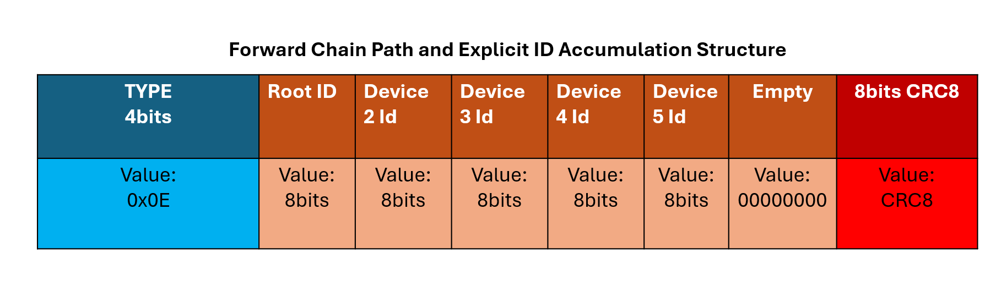
Figure 6: Forward Chain Path and Explicit ID Accumulation.
(Figure Created by PowerPoint).
The complete communication flow and the arbitration logic of Stage 1 are visually modeled in the sequence diagram below (Figure 16).
Stage 2: Forward Chain Path and Explicit ID Accumulation
Once the medium is verified as clear, the Root node initiates the building of the routing path:
- Frame Accumulation: The Root constructs a fixed 8-byte data frame where its own unique Short ID is written into the first slot of a 5-byte payload array (Bytes 1–5).
- Implicit Acknowledgment (ACK): Surrounding nodes hear the frame and calculate a localized Backoff delay based on their unique ID hashes to prevent simultaneous collision. The node with the shortest timer appends its own Short ID to the next empty slot in the frame and rebroadcasts it. When the previous transmitting node hears this updated frame containing its own ID in the chain, it interprets it as an implicit ACK, shuts down its transmission worker, and remains silent.
- Leaf Node Detection: The packet continues to propagate down the linear chain. The last reachable device in that physical branch broadcasts the packet up to 5 times (the retry threshold). If no subsequent node captures the packet to append its ID, the current node mathematically concludes it is a Leaf Node, freezes its routing state, and shifts to Stage 3.
- Starvation Prevention: To avoid channel starvation when multiple nodes compete to append their IDs, each node maintains a dynamic Starvation Counter. The longer a node is blocked from accessing the medium, its random backoff interval is mathematically compressed, giving it higher transmission priority.
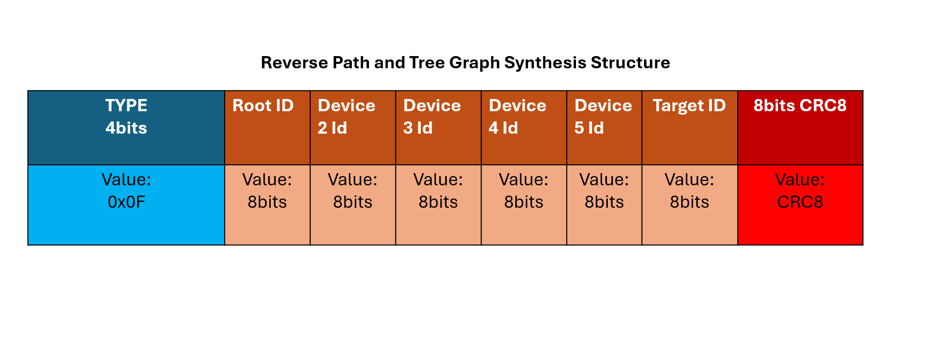Figure 7: Forward Chain Path and Explicit ID Accumulation.
(Figure Created by PowerPoint).
The accumulation of node IDs and the progressive construction of the network chain during Stage 2 are mapped out conceptually in Figure 7 (Forward Chain Path and Explicit ID Accumulation), and its formal execution flow is detailed in the sequence diagram in Figure 17.
Stage 3: Reverse Path and Tree Graph Synthesis
- Targeted Upstream Routing: The identified Leaf nodes reverse the data flow, transitioning into temporary branch roots. Using the accumulated ID array inside the frame, a node looks up the slot immediately to its left (direct ancestor node) to identify its direct physical Parent node.
- Contextual Byte Control: Byte 6 of the standard frame is dynamically refactored during this stage to act as the Target ID field, ensuring that only the explicit parent processes the upstream packet.
- Join Barrier Synchronization: If an intermediate node acts as a common ancestor for multiple topological branches (branches of topological tree from the same direct ancestor node), it executes a Join Barrier. Upon receiving the upstream packet from the first child branch, the parent halts propagation and remains in a listening lock until all expected children have returned their topological maps. Once the barrier is satisfied, the parent merges the branches into a unified tree array and forwards it upstream toward the Root.
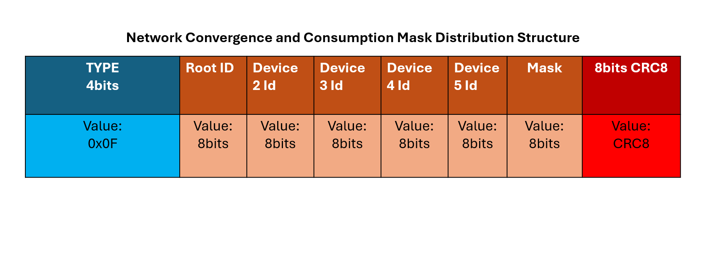
Figure 8: Forward Chain Path and Explicit ID Accumulation.
(Figure Created by PowerPoint).
The reverse topology aggregation and the parent-child joining process of Stage 3 are conceptually mapped in Figure 8 (Reverse Path and Tree Graph Synthesis), and the exact sequence of message exchanges is illustrated in the sequence diagram in Figure 18.
Stage 4: Network Convergence and Consumption Mask Distribution
- The Consumption Mask: Upon receiving the completed tree graph, the Root node holds the comprehensive network topology. To synchronize all nodes, the Root configures Byte 6 to act as a bitwise Consumption Mask, where a bit is flipped to '1' for every active slot containing a valid node (e.g., 0x0F or 00001111 for a 4-node network).
- Down-Tree Propagation: The Root transmits the full topology map down the tree. As each target node captures the frame, it identifies its assigned bit index, verifies its safe delivery, and flips its bit from '1' to '0' (consuming its state).
- Fast Control ACK: To maximize efficiency and prevent transmitter timeouts, the receiving node immediately emits a short, 300 ms continuous tone over the Control Channel back to its parent. This fast acoustic signal serves to silence the parent's retransmission loop without the overhead of a full 16-FSK data packet. The node then updates the Target ID and passes the frame further down the branch.
- Network Convergence: When the final Leaf node consumes the remaining '1' bit, Byte 6 becomes entirely cleared (0x00). All devices lock their internal state machines to Ready mode, and the network successfully silences.
The final map distribution, consumption mask dynamics, and system-wide network convergence of Stage 4 are visually modeled in the sequence diagram in Figure 19.
4.3.3 Fault Tolerance: Dynamic Disconnection Detection
During standard network runtime, a node might leave the room or experience sudden hardware failure. To distinguish between a temporary link dropped due to localized multi-path interference and an actual node disconnection, the protocol implements a Passive Overhearing Mode:
- If a node fails to receive an expected ACK from a neighboring peer after its retry threshold, it refrains from triggering an immediate network reset.
- The node suspends its active worker and opens an unguided listening window, capturing all raw 16-FSK data frames floating across the shared acoustic medium.
- Since every standard data frame explicitly includes the Short IDs of the active routing path in Bytes 1–5, the listening node scans these overheard headers.
- If the silent node's ID is detected within any frame (even those addressed to third-party nodes), it proves the device is alive and transmitting; the issue is marked as a localized link degradation.
- If the passive listening timer expires and the target ID has completely vanished from the air, a definitive Disconnection is declared. The detecting node instantly fires a 20 kHz Discovery tone on the Control Channel, wiping the stale topology tables and forcing an automatic network rebuild.
4.3.4 Mathematical Timing Analysis and Network Convergence Budget
The physical constraints of acoustic data transmission are strictly defined by the symbol duration and baud rate. Operating at a standard 10 Baud rate (where each 16-FSK symbol carries 4 bits of information over a 100 ms duration window), a complete 8-byte (64-bit) data packet requires exactly 1.6 seconds of physical airtime.
Conversely, a continuous control tone (DISCOVERY/BUSY/ACK) requires only 300 ms to establish high-confidence energy integration inside the receiver's FFT bins.

Chapter 5. EXPECTED RESULTS and REALITY
The primary objective of this project was to design and implement a fully functional acoustic communication network, utilizing ultrasonic waves as the physical transmission medium.
In fact, the system is created as a cross-platform mobile application (compatible with both Android and iOS), enabling seamless communication between heterogeneous devices.
Key Technical Specifications:
- Protocol: The Data Link Layer implements a collision avoidance mechanism based on the RTS/CTS (Request to Send / Clear to Send) handshake protocol to ensure reliable data delivery.
- Capacity & Range: The network is designed to support a cluster of at least 3 concurrent nodes within an optimal effective radius of 2 meters.
- Topology: The system supports a many-to-many communication architecture, managing data transfer from multiple emitters to multiple recipients simultaneously.

Chapter 6. UML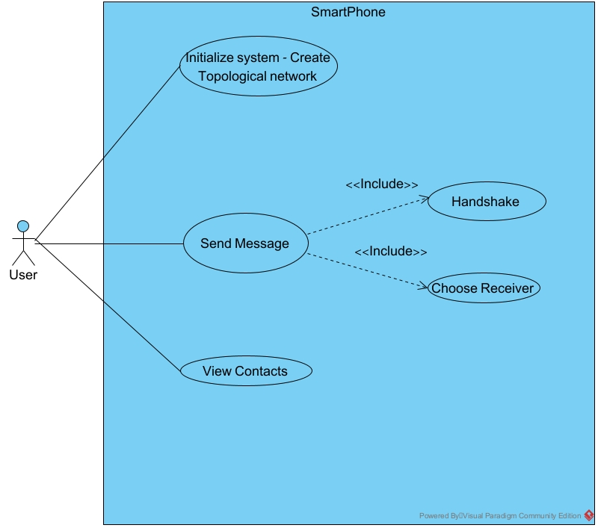

Figure 9: Use Case: Many-to-Many Interaction and Messaging Protocol
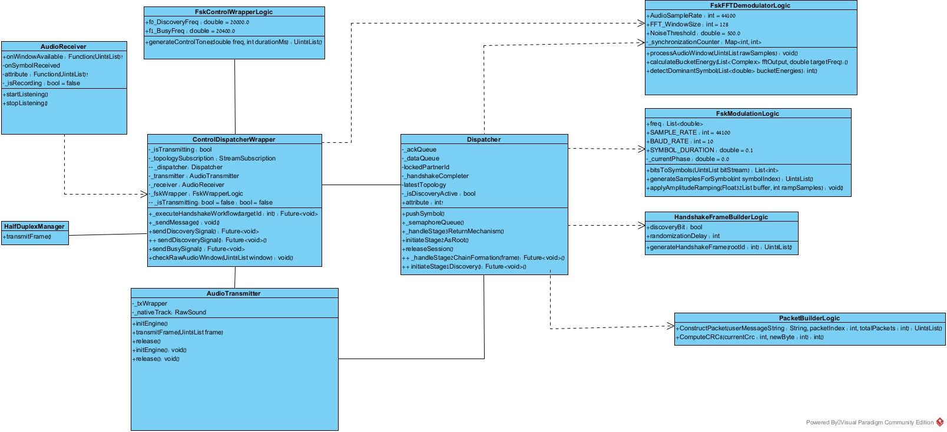

Figure 10: Class Diagram: Structural Design of the entire System
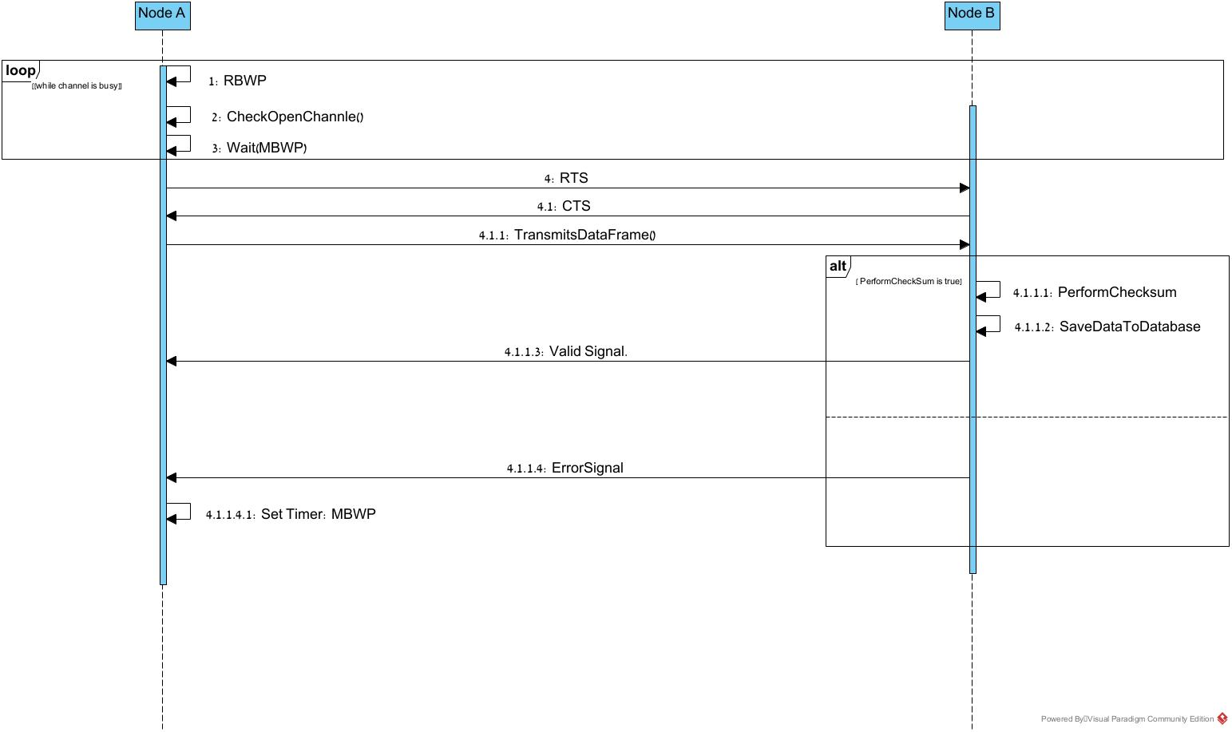
Figure 11: Sequence Diagram: CSMA/CA Protocol with RTS/CTS Handshake Sequence
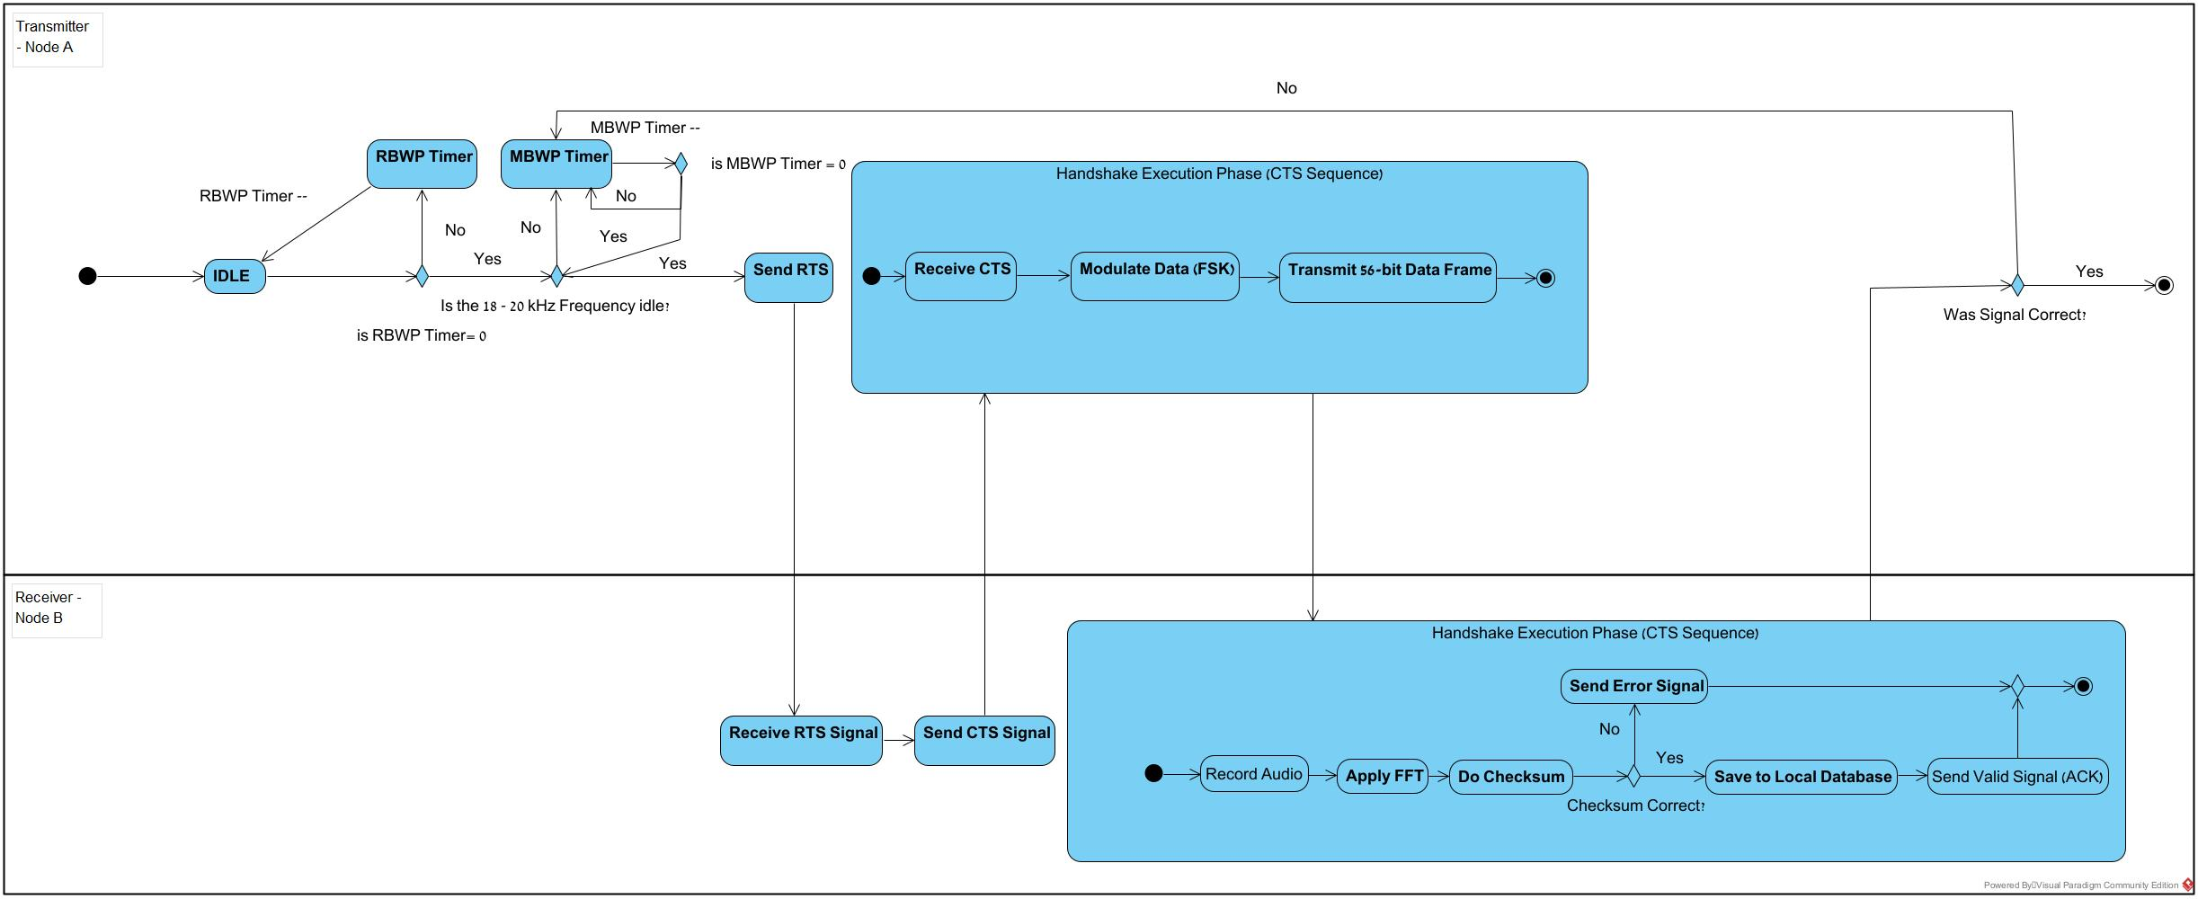
Figure 12: Activity Diagram: CSMA/CA Protocol with RTS/CTS Handshake
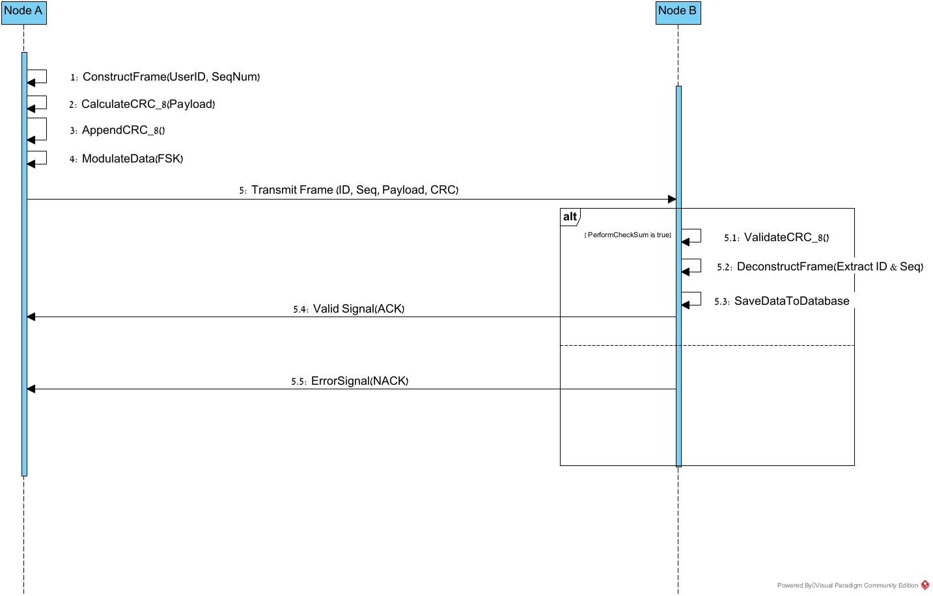
Figure 13: Sequence Diagram: Data Transmission and Frame Verification Protocol
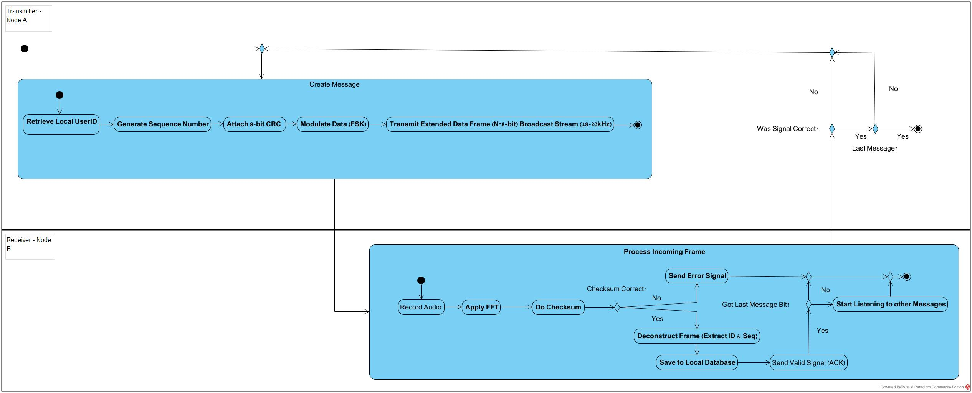
Figure 14: Activity Diagram: Data Framing and Physical Layer
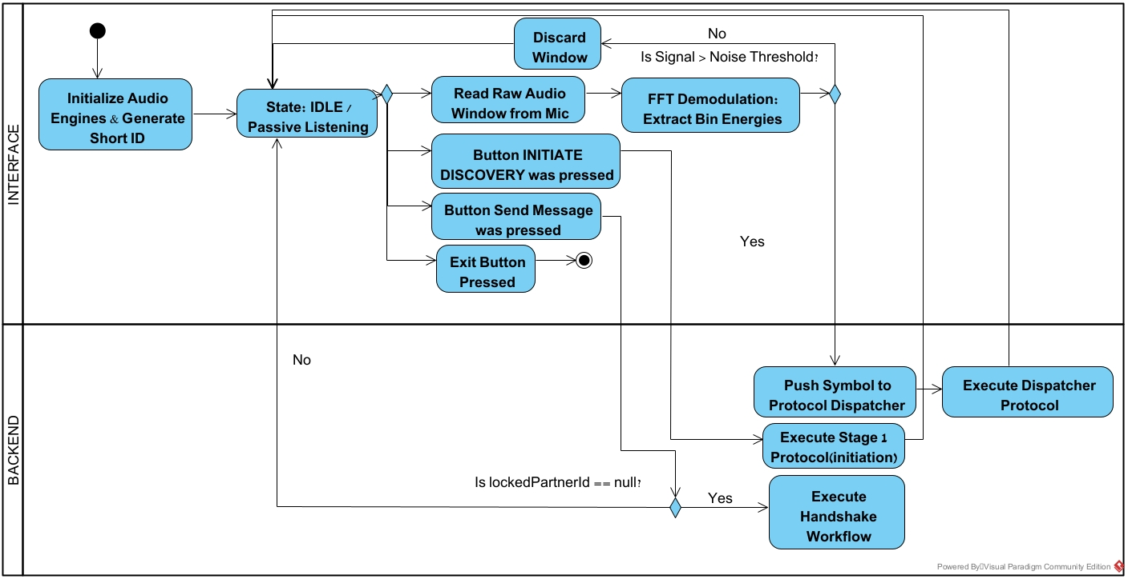
Figure 15: Activity Diagram: API System Flow

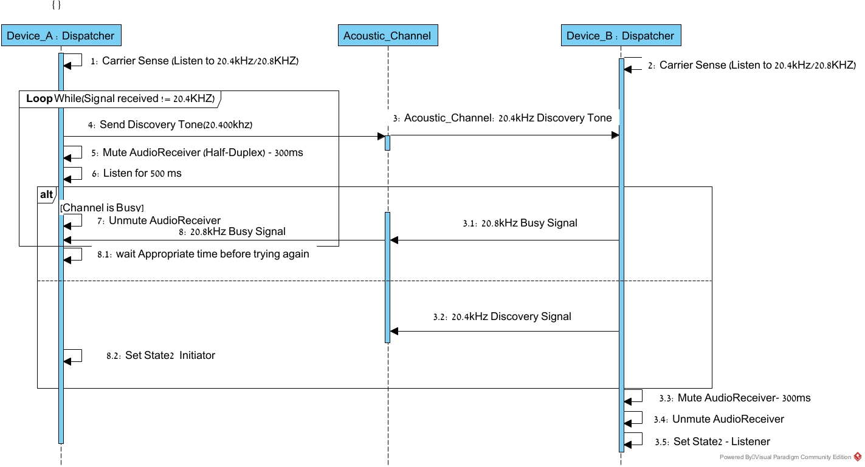
Figure 16: Sequence Diagram: Stage 1 – Discovery
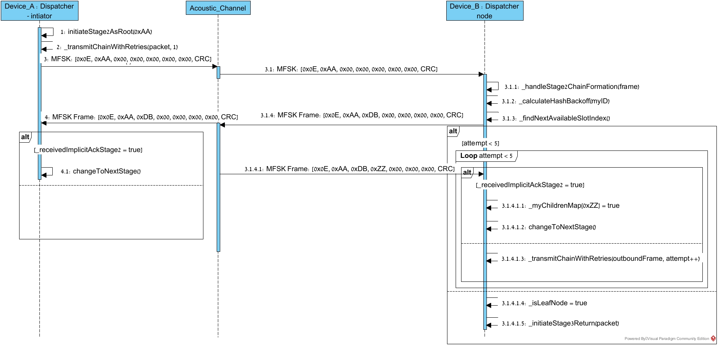

Figure 17: Sequence Diagram: Stage 2 Chain Formation
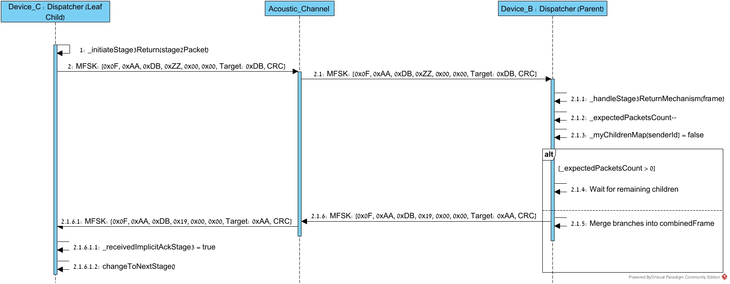

Figure 18: Sequence Diagram: Stage 3 - Return Mechanism
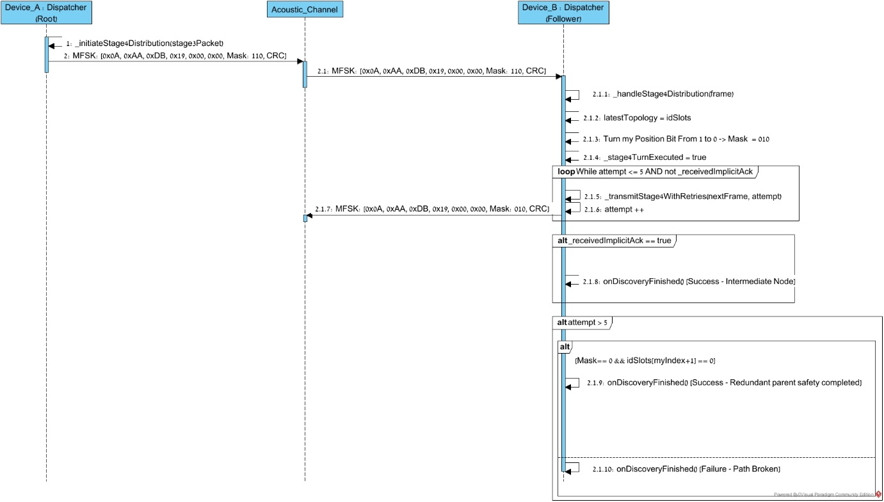

Figure 19: Sequence Diagram: Stage 4 - Final Distribution & Convergence
Chapter 7. Testing and Reality
7.1. Bit Packing And Fragmentation Logic
- Objective: Verify that the ConstructPacket function correctly packs the "Total Packets" and "Current Index" integers into a single byte.
- Procedure: Input Total=3, Index=2. Run the bit-packing logic.
- Success Criteria: The resulting byte must equal 0x32 (Binary 00110010).
7.1.1. CRC Calculation Accuracy
- Objective: Validate the integrity of the CRC checksum algorithm.
- Procedure: Manually calculate the CRC value of the string "TEST". Run the code’s checksum function on the same string.
- Success Criteria: The code output must match the manual calculation exactly.
7.1.2 Packet Serialization
- Objective: Ensure that the raw string is correctly converted into the binary protocol frame.
- Procedure: Pass the string “TEST" to the serializer. Inspect the output bit array.
- Success Criteria: The array must follow the strict order: Preamble -> Sync -> Frag -> Length -> Payload -> Checksum.
7.1.3 Frequency Analysis Algorithm
- Objective: Test the FFT logic using a mathematically generated array
- Procedure: Feed an array containing a pure mathematical sine wave of 18kHz into the detection function.
- Success Criteria: The algorithm must return to a significantly higher magnitude for the 18kHz bin compared to the 20kHz bin.
7.2 Physical Layer Testing
7.2.1. Bit Duration And Timing
- Objective: Confirm that each bit lasts exactly 0.5ms as defined.
- Procedure: Record the transmission of a single bit using an external PC with audio editing software (Audacity). Measure the waveform length.
- Success Criteria: The waveform duration must be 0.5ms

7.3. Integration Testing
7.3.1. Single Packet Transmission
- Objective: Test the successful transfer of a short message.
- Procedure: Tx sends the string "TEST".
- Success Criteria: Rx decodes the message correctly, checksum validation passes, and the text "TEST" appears on the screen.
7.3.2. RTS/CTS Handshake Verification
- Objective: Ensure the collision avoidance mechanism works.
- Procedure: Tx initiates a transmission.
- Success Criteria: Tx waits for CTS. Rx sends CTS upon hearing RTS. Tx only begins data transmission after receiving the CTS.
7.4. Field Testing
7.4.1 Maximum Effective Range
- Objective: Determine the maximum distance for reliable communication.
- Procedure: Place devices 10cm apart and increase distance in 10cm increments until decoding fails.
- Success Criteria: Document the distance where communication is failed.
7.4.2 Noise Immunity
- Objective: Validate performance in a noisy environment.
- Procedure: Perform transmission while sending external noise near the receiver.
- Success Criteria: The system should successfully filter out the noise
7.4.3 Wall/Barrier Penetration Test
- Objective: Determine the signal's ability to diffract around or penetrate obstacles, verifying if direct Line-of-Sight (LOS) is mandatory.
- Procedure:
  - Establish a stable connection between devices at a distance of 2 meters.
  - Place obstacles of increasing density directly between the speaker and microphone:
    - Level 1: A sheet of paper.
    - Level 2: A human body.
    - Level 3: A solid wooden door or wall.
- Success Criteria:
  - Pass: The system must accurately report signal loss or checksum failure when the signal is blocked. It must not crash or display random garbage data.
7.4.4. Battery And Thermal Stability
- Objective: Ensure the app does not crash or overheat during continuous use.
- Procedure: Run a continuous transmission loop for 10 minutes.
- Success Criteria: App remains stable, no "Application Not Responding" errors.
Chapter 8. FR\NFR REQUIREMENTS:
Functional Requirements:
- The system must utilize Binary Frequency-Shift Keying (BFSK) to encode digital data into ultrasonic tones between 18 kHz and 20 kHz.
- The system must capture real-time audio and apply Fast Fourier Transform (FFT) to accurately decode binary bits.
- The system must implement a "Listen-Before-Talk" mechanism utilizing unique, prime-number-based backoff timers (RBWP and MBWP) to prevent data collisions.
- The system must perform a Request to Send (RTS) and Clear to Send (CTS) sequence to reserve the channel and eliminate the "Hidden Node Problem”.
- The system must append a 8-bit CRC checksum to each variable-length data frame, and the receiver must validate this checksum before processing the data.
- The system must return a "Valid Signal" (ACK) upon successful validation or an "Error Signal" (NACK) to trigger retransmission.
- The system must support a many-to-many architecture capable of managing at least 3 concurrent nodes within a 2-meter radius.
- The system must validate user encounters (ID and timestamp) must be committed to a local device database.
Non-Functional Requirements:
- Transmission must remain above the standard human hearing threshold (typically 18 kHz+) to ensure a non-intrusive user experience.
- Each bit must have a duration of 0.5ms to allow for signal rise time and to mitigate Inter-Symbol Interference (ISI) caused by echoes.
- The system must achieve successful data transfer in the presence of ambient noise and multipath propagation.
- The network must operate on a peer-to-peer basis without requiring SIM cards, Wi-Fi infrastructure, or cellular coverage.
- The system must operate at safe power levels for the human body, avoiding the tissue-heating concerns associated with high-power RF.
Chapter 9. Future Work and Scalability Horizons
9.1 Introduction and Physical Layer Bottlenecks
The current architecture of the developed many-to-many ultrasonic protocol is physically constrained by an operational bandwidth tuned to a 10 Baud rate, meaning each 16-MFSK acoustic symbol requires a rigid duration window of 100 ms. Consequently, transmitting a full 8-byte (64-bit) data packet consumes exactly 1.6 seconds of physical airtime. Under these specific acoustic constraints, the grand time budget required to achieve full topological convergence in a small cluster of 5 concurrent devices amounts to 29.6 seconds. While this design successfully mitigates localized multi-path propagation and room echoes within a 2-meter operational radius, it imposes an algorithmic ceiling on network scalability; adding more concurrent nodes would exponentially bloat latency and severely degrade channel efficiency.
To transition this proof-of-concept into a massive-scale, high-density acoustic network, future iterations must prioritize breaking this physical baud rate barrier. Assuming advancements in DSP or the integration of higher-frequency, low-latency transducers allow for a compressed symbol duration. This chapter outlines the theoretical and structural expansions designed to scale the protocol.
9.2 Distributed Multi-Initiator Discovery Framework (Starvation Mitigation)
In large-scale acoustic network deployments exceeding the current 5-device baseline, the legacy starvation prevention mechanism—which relies solely on dynamically compressing randomized backoff windows—becomes insufficient to prevent long-term channel blocking. To ensure absolute fairness across an expanded medium, the protocol can be enhanced with a Distributed Multi-Initiator Discovery Framework:
- Passive Starvation Monitoring:
Each individual node will actively maintain an internal starvation thread, tracking the exact duration its outbound data packets sit idling in the FIFO queue without successfully securing a transmission slot in the active topological chain.
- Forced Discovery Disruption:
If a node detects that its local starvation metrics cross a critical predefined threshold (Timeout), it will be granted systemic authorization to forcefully disrupt the current network state via the dual-frequency Control Channel.
- Chain Refactoring:
The starved node will broadcast a continuous, unmodulated tone at $f_{0}={20,000}_{Hz}$ (the DISCOVERY token) directly over the control channel, forcing all surrounding nodes to instantaneously wipe their stale routing tables and execute an immediate, micro-second network rebuild. This ensures that hidden or suppressed devices can dynamically re-insert themselves into a favorable topological position and flush their pending queues.
9.3 Multi-Hop Mesh Relay Architecture (Range Extension)
The existing link layer operates under a strict geographical assumption that all participating nodes reside within a direct, line-of-sight (LOS) acoustic reception zone where every device can explicitly hear both data frames and control channel signaling. A vital future architectural milestone is the implementation of a Multi-Hop Mesh Relay framework to bypass physical distance limitations:
- Store-and-Forward Relaying:
In scenarios where Node 1 needs to route critical metrics to Node 3, but the two devices are separated beyond the effective acoustic radius or blocked by dense physical barriers (such as solid walls or human bodies that highly attenuate ultrasound waves), the intermediate Node 2 will automatically function as an acoustic bridge.
- Algorithmic Flow:
Node 1 will encapsulate its payload and flag Byte 6 (the Context/Routing Byte) to explicitly designate Node 2 as a hop-by-hop relay node. Node 2 will process the incoming frame, store it temporarily within its local buffer queue, execute standard CSMA/CA carrier-sensing to verify that its localized environment is clear, and rebroadcast the data frame to its final destination at Node 3. This relay topology will safely scale the network across expansive multi-room complexes (e.g., medical wards or secure laboratory facilities) while preserving the natural boundary security advantages inherent to sound containment.
9.4 Dynamic Framing and Expanded Addressing Space
The legacy frame structure relies on a highly optimized, fixed 8-byte layout, reserving exactly 5 bytes (Bytes 1–5) to accumulate the Short IDs of active nodes in the routing path. This structural limitation was intentionally designed to freeze airtime at 1.6 seconds under the 10 Baud constraint.
Once physical layer optimization increases the operational Baud rate, the data link layer can be safely refactored to support open-ended scalability using a variable-length architecture:
- Variable-Length Data Framing:
The system will support a dynamic number of connected nodes (instead of the current fixed amount). The packet header will leverage a dynamic Length Field (originally specified in Byte 4) to dictate variable payload bounds on-the-fly. Powered by high-speed symbol execution, frames can expand dynamically to accumulate 10, 20, or more node IDs within a single forward discovery cycle without incurring prohibitive latency penalties.
- Expanded Short ID Address Space:
The current 4-bit/1-byte allocation for unique node IDs restricts the network cluster to a narrow set of concurrent participants. Expanding the Short ID field to a dedicated 2-byte (16-bit) structure will instantly expand the available addressing space to 65,536 unique identifiers. This allows an unlimited volume of heterogeneous mobile devices to seamlessly cross-register, discover, and communicate within the acoustic mesh network without encountering address collision risks.
Chapter 10. Reference
[1] ref: https://www.rfpage.com/what-is-frequency-shift-keying-fsk/
[2] ref: https://en.wikipedia.org/wiki/Frequency-shift_keying
[3] ref: https://www.ionos.com/digitalguide/server/know-how/csmaca-carrier-sense-multiple-access-with-collision-avoidance/
[4] J. G. Proakis and M. Salehi, Digital Communications, 5th ed. New York, NY, USA: McGraw-Hill, 2008.
[5] RF Wireless World, "NFC vs. RFID vs. Bluetooth vs. Wi-Fi: Key Differences Explained," rfwireless-world.com. [Online]. Available: https://www.rfwireless-world.com/terminology/nfc-vs-rfid-vs-bluetooth-vs-wifi.
[6] M. Safadi and R. Hassan, Smart Visit Card (SVC) An Android-Based Application for Managing Visit Cards” Final Project Report, Dept. Software Eng., Braude College of Engineering, Karmiel, Israel.
[7] T. Zilberman and A. Havkin,” Ultra Sound Data Transfer Many To Many”," Final Project Report, Dept. Software Eng., Braude College of Engineering, Karmiel, Israel.
[8] T. Fares and F. Jaraisy, Smart Visit Card Inaudible Information Transfer between Android Based Devices
," Final Project Report, Dept. Software Eng., Braude College of Engineering, Karmiel, Israel.
[9] Tanenbaum, A. S., & Wetherall, D. J. (2011). Computer Networks (5th ed.). Pearson.
[10] Szabo, T. L. (2004). Diagnostic Ultrasound Imaging: Inside Out. Elsevier Academic Press.
[11]ref:https://www.researchgate.net/publication/304130724_High_Data_Rate_Ultrasonic_Communications_for_Wireless_Intra-body_Networks

